Exercise: Git and GitHub
Problems for exercises and homework for the "Software Technologies" course @ SoftUni

Register a GitHub Profile
Register for a free developer account at GitHub: http://github.com/
Add a screenshot to your profile here:
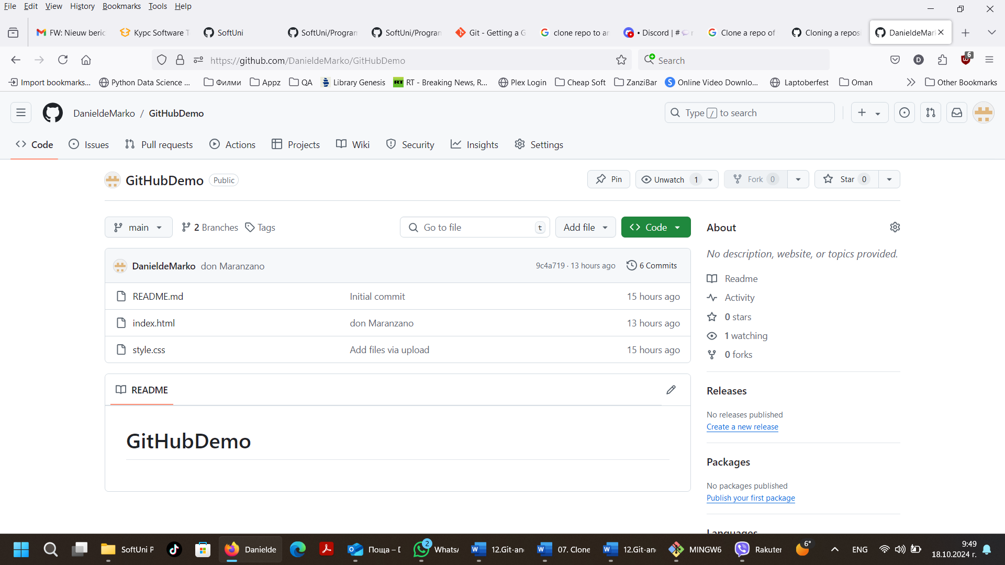

Clone a Repo
Navigate to https://github.com/SoftUni. Find a repo that you like. We have books that might interest you. Clone a repo of your choice in your profile.
Provide a picture of the cloned repo here:
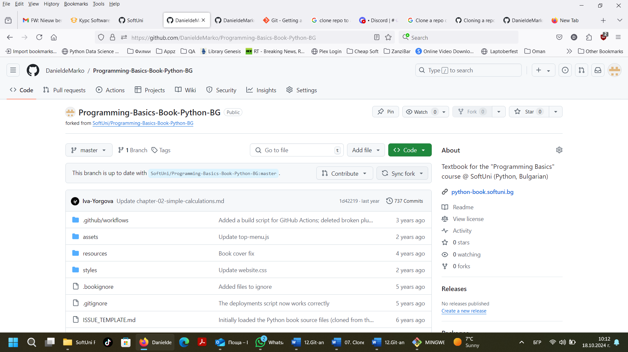
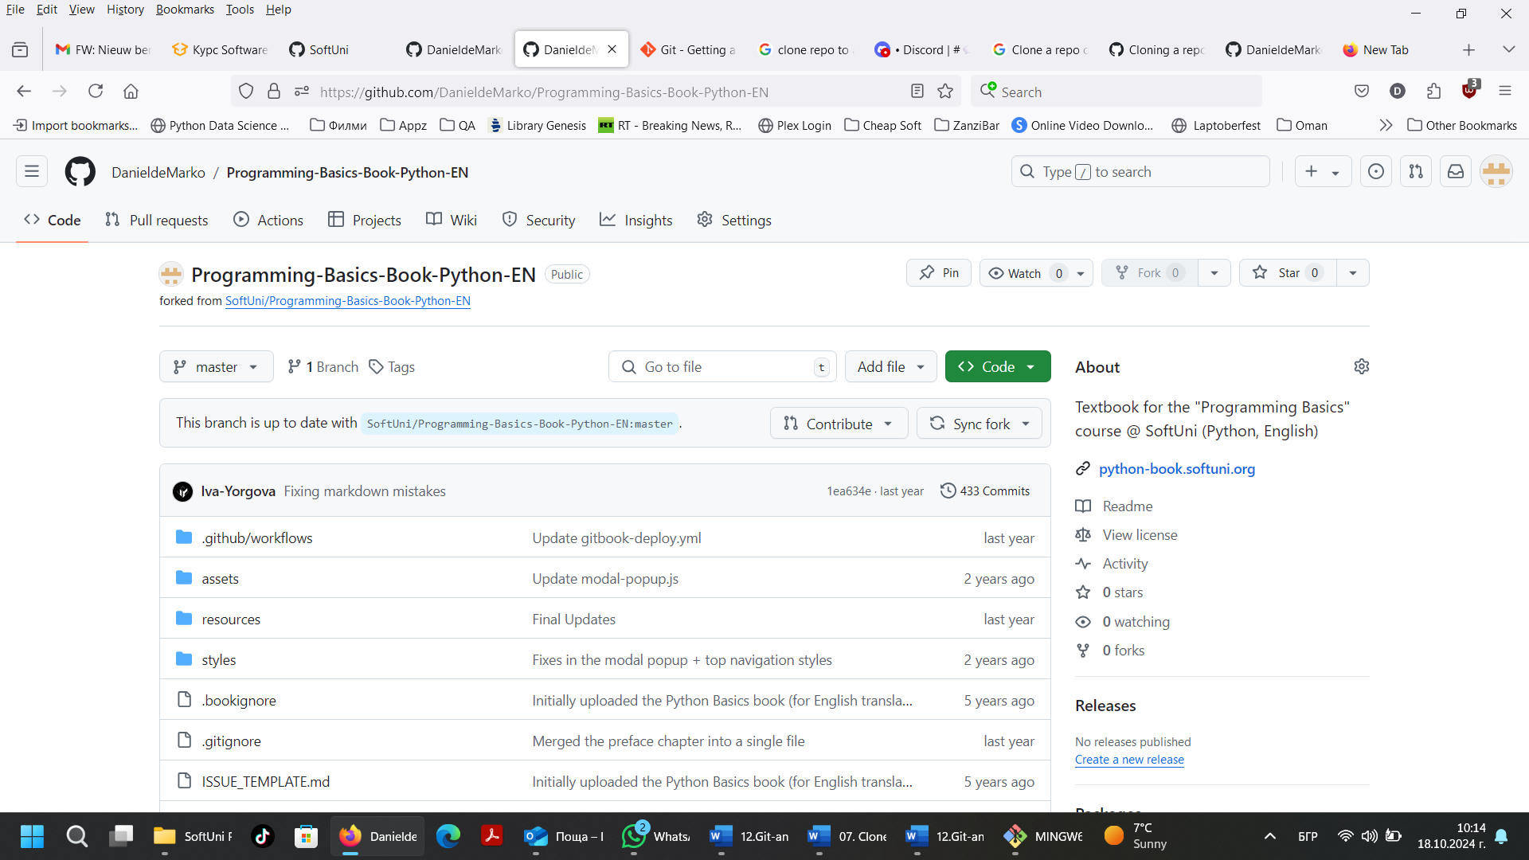

Download a local copy of the repo to your computer
Using GitBash or GitHub Desktop, download a local copy of the repo to your computer.
Add a picture of the folder here:
